**Status Report Handout**

**Douglas Raymond 100904379**

The portion of the tricycle I designed was the outer shell. The dimensions and the appearance were of the most significance to my sketches. I maintained a modern and streamlined design to appeal to an urban commuter. Each portion of the shell has been carefully considered as no space can be squandered.

The dimensions of the tricycle has been specifically tailored to the size of Canadian bike lanes, enough space has been provided to comfortably fit the user as well as incorporate additional safety features. The shape also considers the winter season and minimizes the collection of snow on the roof. Aerodynamics have been carefully considered, making sure the weight of the bicycle is efficient for the seasons and tasks required. Previously the dimensions of the vehicle were 2.78m long by 0.85m wide by 1.20m high.

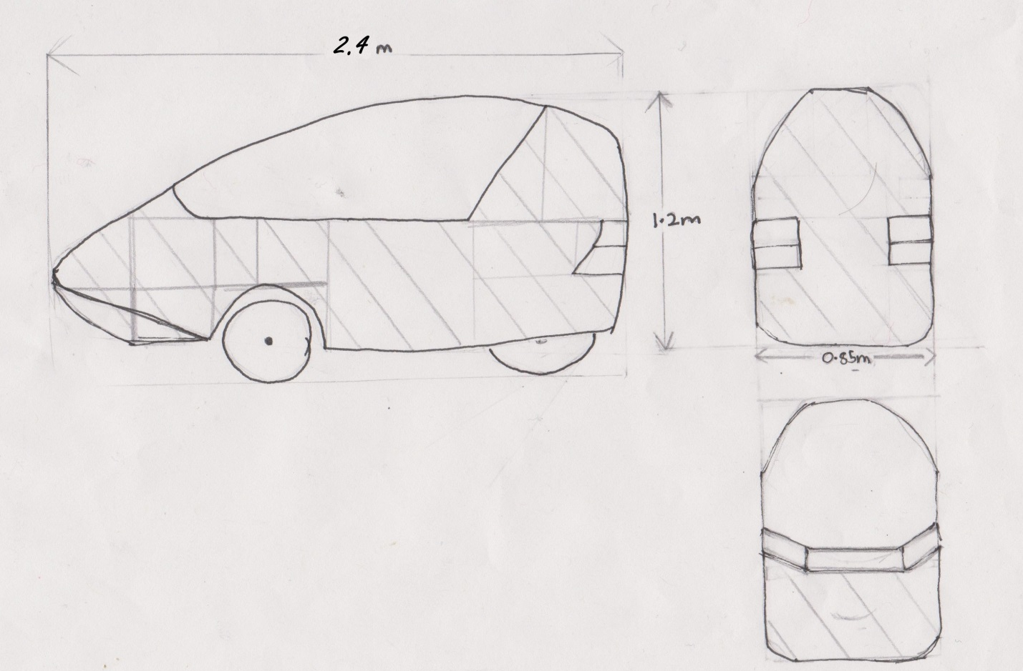

References: